Technical Contribution – Data Layer & Storage
Project: Serverless Payroll Processing & Payslip Delivery Engine
- Overview
As the Data Layer & Storage Engineer in a team of three members, I was responsible for designing and implementing the data storage layer of the Serverless Payroll Processing & Payslip Delivery Engine on AWS. My work focused on creating the database schema, preparing payroll datasets, configuring cloud storage, and enabling seamless integration with the payroll processing pipeline.

- Responsibilities
- Designed the payroll data model using Amazon DynamoDB.
- Created and configured all required DynamoDB tables.
- Populated realistic employee payroll datasets for testing and integration.
- Configured Amazon S3 storage for generated payslips.
- Defined the storage hierarchy for payroll documents.
- Supported the payroll processing workflow by providing a structured and scalable data layer.
- Prepared the storage layer for payroll history and audit requirements.

DynamoDB Data Model
I designed and implemented the following DynamoDB tables:
1. employee_master
Stores employee master information required for payroll processing.
(a) Attributes
- employee_id
- employee_name
- email
- department
- designation
- employment_status
- joining_date
(b) Partition Key
- employee_id

Fig 1: employee_master table
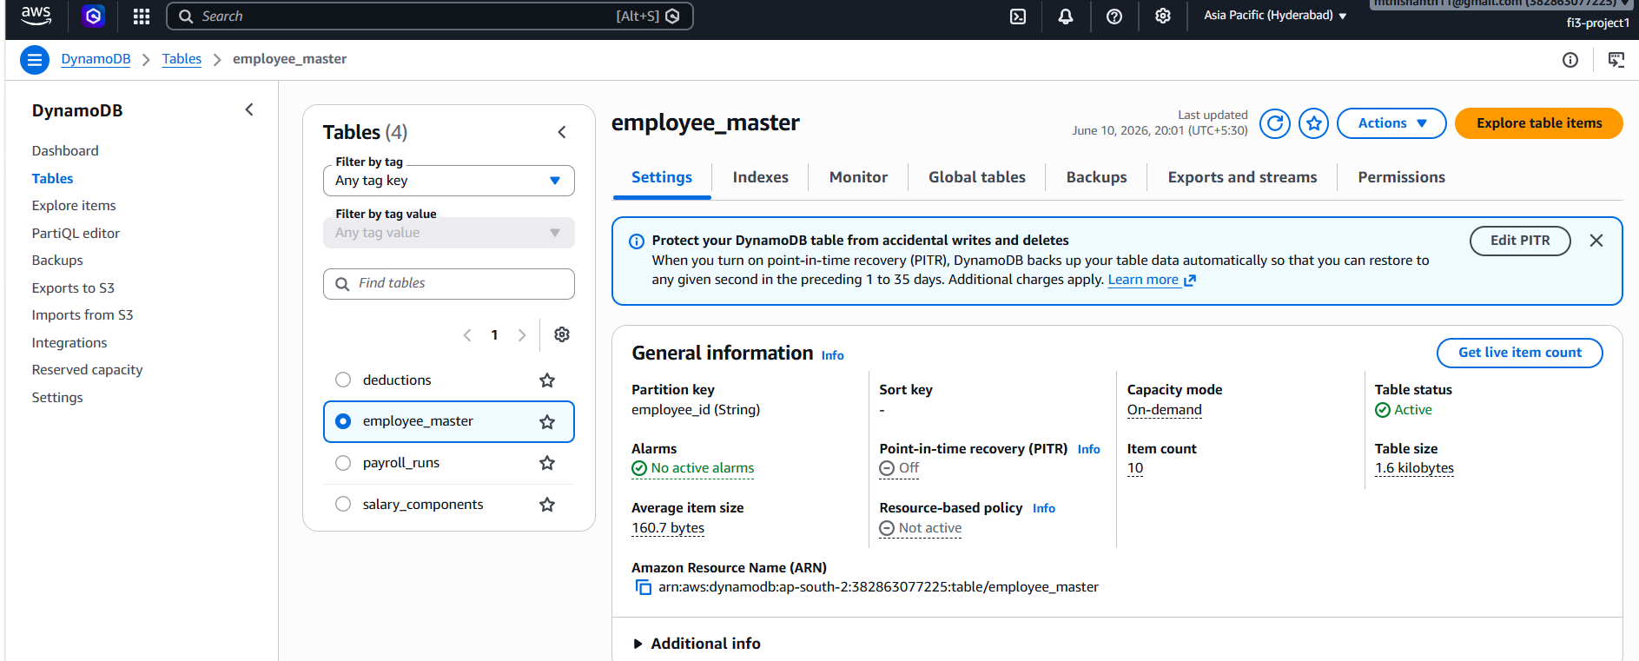

Fig 2: employee_master table (Items)
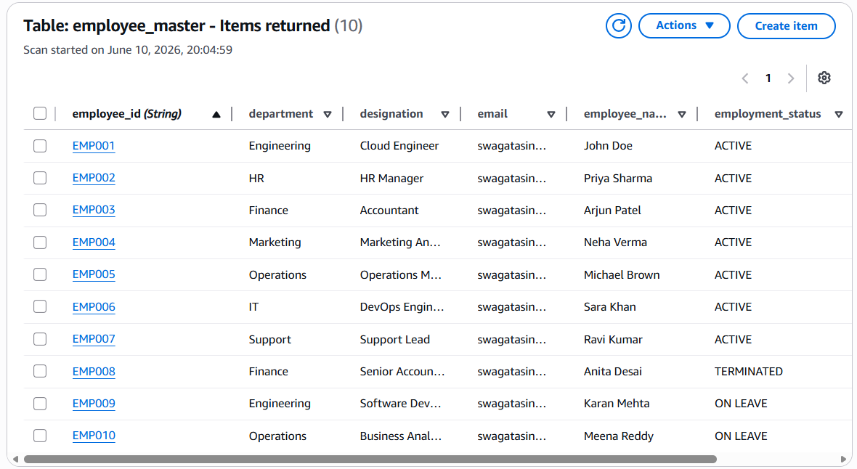

2. salary_components
Stores employee salary structure used for payroll calculations.
(a) Attributes
- employee_id
- base_salary
- hra
- transport_allowance
- special_allowance
(b) Partition Key
- employee_id

Fig 3: salary_components table
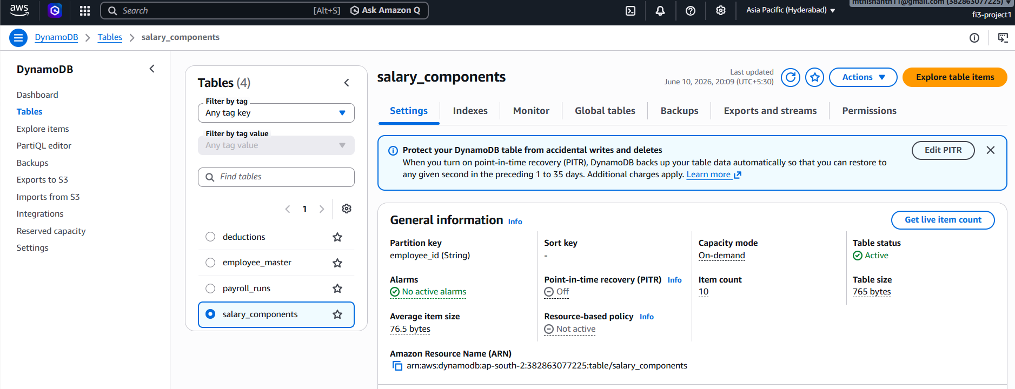
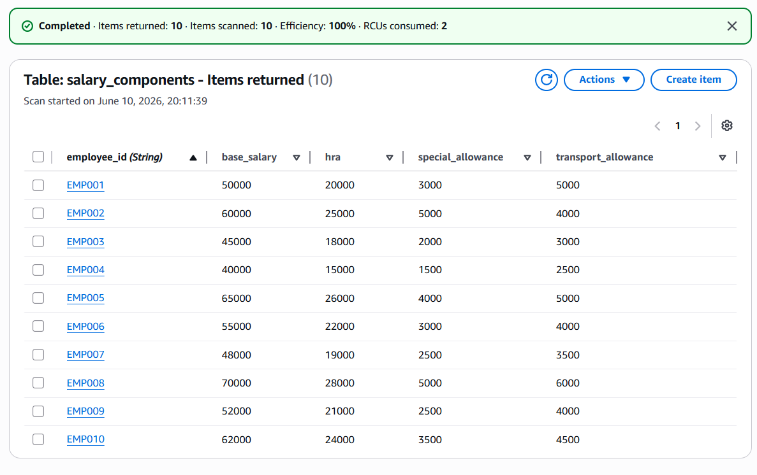
Fig 4: salary_components table (Items)

3. deductions
Stores employee deduction details.
Attributes
- employee_id
- pf_percentage
- professional_tax
- tds_percentage
- loan_deduction
Partition Key
- employee_id

Fig 5: deductions table
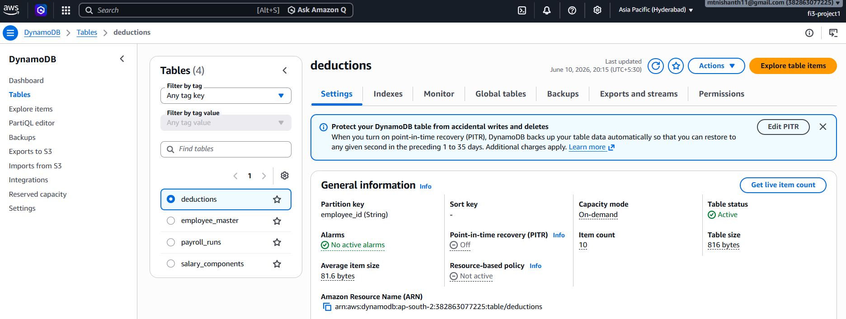

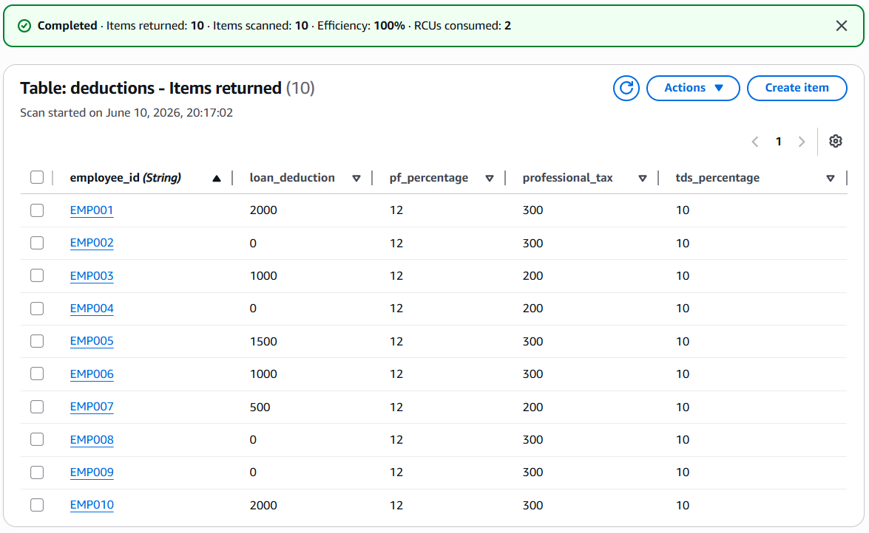
Fig 6: deductions table (Items)

4. payroll_runs
Designed to maintain payroll execution history and audit records generated during payroll processing.
(a) Attributes
- run_id
- employee_id
- month
- gross
- deductions_total
- net_pay
- status
- payslip_s3_key
Fig 7: payroll_runs tables
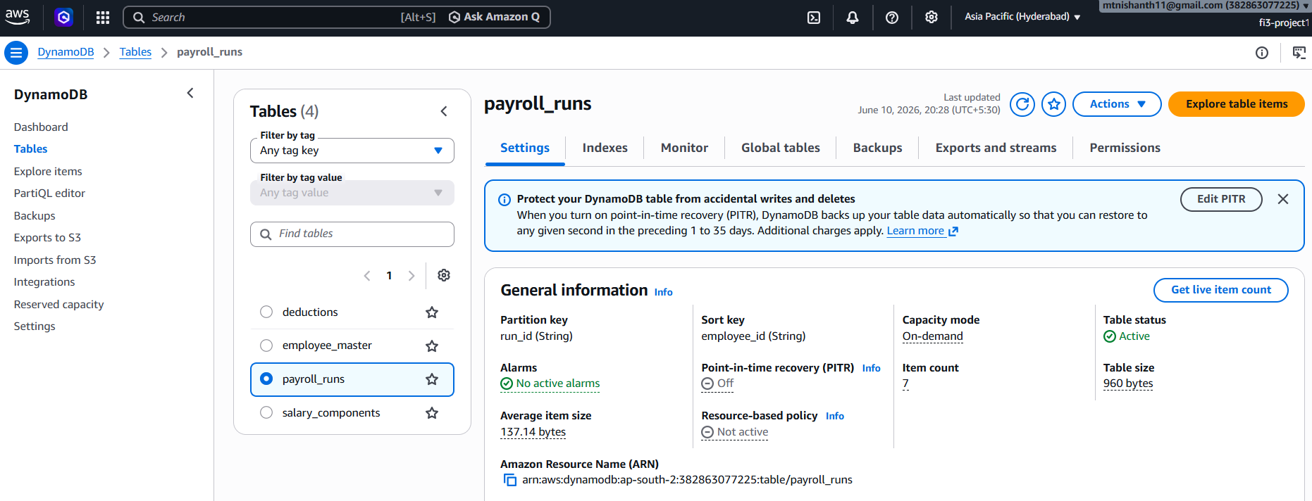

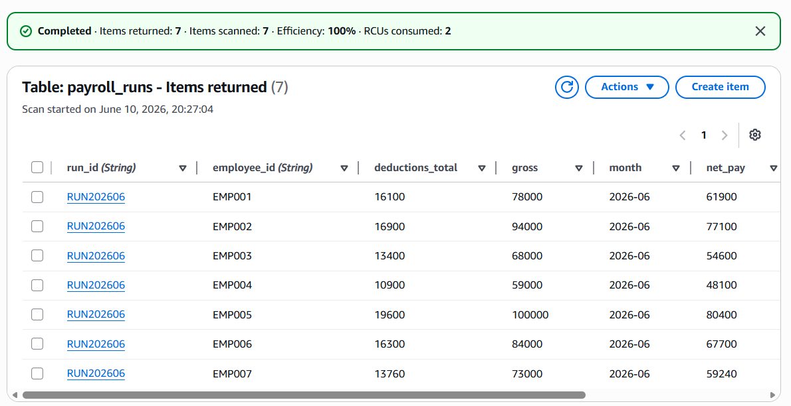
Fig 8: payroll_runs (Returned Items)

- Test Dataset Preparation:
Created sample payroll data for multiple employees representing different employment scenarios, including:
- Active Employees
- On Leave Employees
- Terminated Employees
This dataset enabled validation of payroll business rules and end-to-end integration testing.

Amazon S3 Storage Configuration
Configured Amazon S3 as the storage layer for generated payroll documents.
Folder hierarchy:
payslips/
└── 2026/
└── 06/
EMP001.pdf
EMP002.pdf
EMP003.pdf
The storage structure supports organized archival and retrieval of employee payslips.

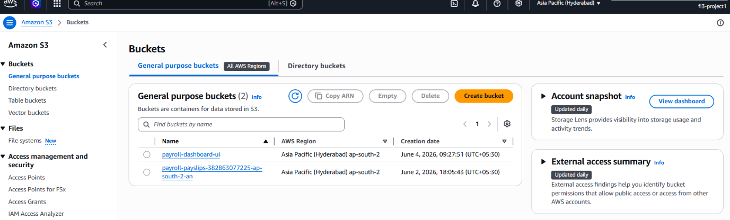
Fig 9(a): Buckets

(b)
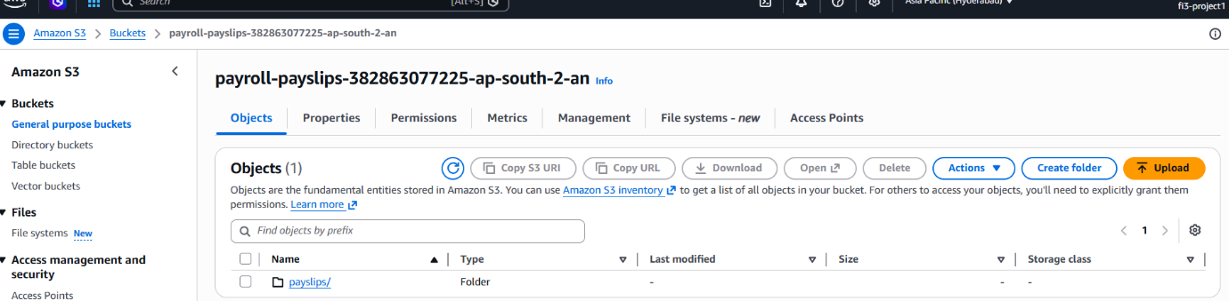

(c)
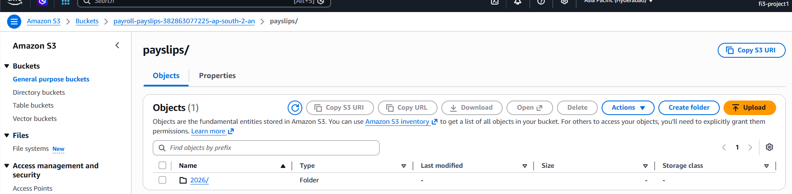
(d)
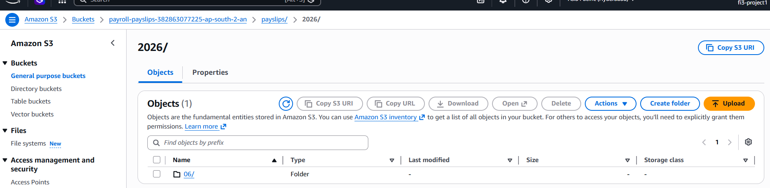

(e)
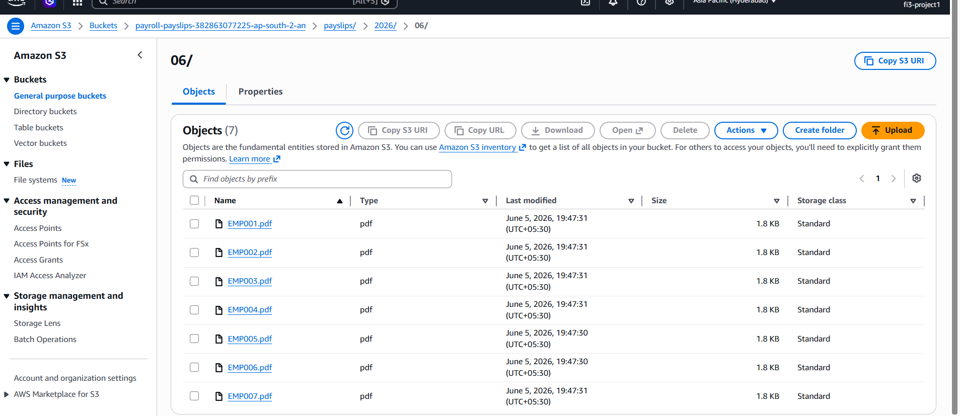

Integration Support:
The data layer was designed to integrate with the serverless payroll workflow:
- Employee information retrieved from employee_master
- Salary details retrieved from salary_components
- Deduction information retrieved from deductions
- Payroll execution results stored in payroll_runs
- Generated payslips stored in Amazon S3
This design enabled seamless interaction with AWS Lambda, Amazon SQS, and Amazon SES during payroll processing.

Key Skills Demonstrated:
- Amazon DynamoDB Data Modeling
- NoSQL Database Design
- AWS Cloud Storage (Amazon S3)
- Serverless Data Architecture
- Payroll Data Management
- Data Normalization
- AWS Console Configuration
- Cloud Integration Support

Outcome
The implemented data layer provides a scalable and organized foundation for payroll automation by supporting salary calculations, payroll history management, secure payslip storage, and seamless integration with the serverless processing pipeline. My contribution ensured that the storage architecture was reliable, integration-ready, and aligned with AWS serverless best practices.

Made by:
Swagata Sinha
(AWS Cloud Intern)

